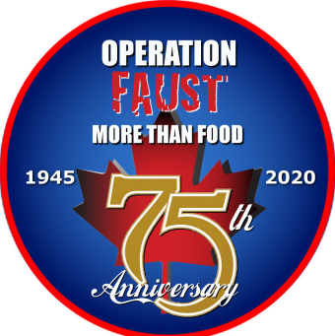

KEEP THEM ROLLING
OPERATION FAUST
CONCEPT

The KTR contact and head of Operation FAUST 2020 is Johan Goudkuil goudkuilj@gmail.com +31643079802

The program for the 75th anniversary of liberation from the Netherlands and the remembrance for the “Op Faust” through “Keep Them Rolling “ in May 2020.
- on the 1st off May making base camp at “Hoekelum” this ground is lying on route to the Nude the Melfa route.

- on the 2nd off May Transfer from the food creates from the sponsor to KTR in Nijmegen at historical ground where in 1945 was the food depot from here they transported it to the Nude. We go in convoy transporting the food creates to the ENKA factory. There will be a ceremonie and placing a plate on the wall off the old factoryl in remembrance that there was in 1945 a food depot under supervision off the 49st West Riding div. The transportation unit from this div who also played a role in transportation off food to the Nude .
after this ceremonie we go to the basecamp.

- On the 3rd off May we have no official activity, members can go on there one way driving a route.

- On the 4th off May we have do a route from Ede basecamp to Leusden from there to Achterveld. In this place where in 1945 the negations between the Germans and the liberation forces to make a agreement for food air droppings and food transportation over land. We will make a historical redo off it and we will make use from reenactors to make the picture complete.

- On the 5th off May we do the “Polar Bears” route from basecamp over the Utrechtse heuvelrug through several towns to remember the liberation, we have on the and a defile through a part off Utrecht and a static show on the malibaan. Here and we will transfer the food creates to a nonprofit organization who distribute the food to the people who need it.

We will have a fest evening on the 2nd or the 5th off May.

