Readings in Operations MANNA and FAUST
April-May 1944

The Western Netherlands
In the western Netherlands, the 1st Canadian Corps, comprising the 1st Canadian Infantry Division and the 5th Canadian Armoured Division under the command of Lieutenant-General Charles Foulkes, was responsible for the liberation of the area north of the Maas River. This region includes the major cities of Amsterdam, Rotterdam and The Hague, where the people were at the end of their endurance from the misery and starvation that had accompanied the "Hunger Winter." Food supplies in the cities were exhausted, fuel had run out almost entirely, and transportation was virtually non-existent. Thousands of men, women, and children had perished.
An assault on Arnhem began on April 12, and, after two days of intense house-to-house fighting, the town was liberated. The 5th Canadian Armoured Division then dashed northward to the Ljsselmeer River, some 50 kilometres away, to cut off the enemy forces in Apeldoorn facing the 1st Canadian Division. The Canadians liberated Apeldoorn on April 17.
By April 28, the Germans in western Holland had been driven back to a line running roughly between Wageningen through Amersfoort to the North Sea, known as the Grebbe Line. On that day a truce was arranged, fighting ceased in western Holland, and several days later food supplies began to move through for the starving people. No part of Western Europe was liberated at a more vital moment than the west of the Netherlands, and the Canadian soldiers who contributed so immensely to that liberation were cheered and greeted with great joy.
On April 25, the American and Russian troops met on the Elbe River. A few days later Hitler committed suicide in Berlin, where he had been encircled by the Russians. The war ended a week later. On May 5, in the village of Wageningen, General Foulkes accepted the surrender of the German troops in the Netherlands. General Simonds of the 2nd Canadian Corps, in Bad Zwischenahn, did the same on his front. The formal German surrender was signed on May 7, 1945, at Reims in France.

Mar 26 The American Seventh Army crosses the Rhine at Worms.
Mar 28 After bridging the Rhine, Canadian units begin battle, lasting three days, for the German town of Emmerich, to the east of Nijmegen.
Mar 30 At the (82m-high) Elterberg, 4 million grenades land among the trees before the area is cleared of Germans, Allied units cross the Dutch border in the Achterhoek region between Elten and Milligen, south east of Arnhem. Enschede suffers another Allied air attack.
Mar 31 After a battle, British units liberate Winterswijk. Mar Black marketeers trade cheese for f26.00 per 100 grams.
April 02 Seyss-Inquart talks with Dutch top civil servant Hirschfeld (Secretary-General, Trade and Commerce), proposing a truce to facilitate large-scale food transports into hunger-stricken, densely-populated Western Netherlands. The British take Ruurlo; Oldenzaal freed.
Apr 03 Canadians take Didam, Lochem, Zevenaar, Borne and Holten.
Apr 04 Mussert returns to residence at The Hague. The British liberate Denekamp, and Canadians free Delden after heavy fighting the. Almelo welcomes Canadians.
Apr 05 Canadians clear Warnsveld, Albergen and Tubbergen of German troops. Fierce battle for Wierden begins. In a solo-action, resistance man H. Michel takes forty Germans prisoner in Aadorp. In a clash in Beerzerveld, Germans kill three resistance men, wound two others. Vriezenveen and Vroomshoop free. Canadians reach Coevorden from Germany.
Apr 06 The Soviets cancel their non-aggression pact with Japan. 800 Georgian Wehrmacht conscripts start uprising on Texel. Canadians take Daarle, arrive in Hellendoorn. French airborne troops land in Drenthe, Germans kill over seventy civilians, resistance men during the following days.
Apr 07 Tragic accident at the Molenberg (Doetichem): three children and four teenagers killed while playing with landmines.
Apr 08 At the Twentol factory in Deventer, Germans kill five members of the resistance who tried to thwart destruction of nearby bridge, and shoot a soldier who refuses to take part in the execution. In Oxe, Germans execute ten resistance men at the estate Oxerhof but let go 30 others. Canadians reach Dedemsvaart. RAF strafes and bombs Meppel's railway station. Canadian units scout eastern outskirts of fortified Meppel. Resistance in Friesland mobilizes, begin frustrating German attempts to destroy bridges, thus keeping small enemy units occupied.
Apr 09 Top Dutch officials discuss German truce offer with resistance commander Koot.
Apr 10 Canadians liberate Deventer, Germans destroy IJssel bridge. Wesepe free. General Blaskowitz takes command of Wehrmacht in Western Netherlands.
Apr 11 Allies liberate concentration camp Buchenwald, Canadians cross IJssel near Gorssel and push toward Wilp, east of Apeldoorn. Resistance liberates Raalte. Ommen, Ruinen, Smilde, Dwingeloo and Ter Apel free. Allies reach Hoogeveen.
Apr 12 President Roosevelt dies, Truman successor. Battle for Zutphen ends when Canadians cross IJssel to silence enemy fire. With the exception of Doesburg, Achterhoek free. Negotiations for truce between top Dutch officials and Seyss-Inquart. Canadians launch second Battle of Arnhem, cross IJssel at Westervoort. Heavy artillery shelling destroys much of Arnhem. Canadians take Heino. Beilen, Diever, Steenwijk and Westerbork free. Canadians liberate heavily-damaged Hooghalen. Belgians free Veele in Groningen. Local Gestapo thwarts plans of Dutch Nazis to kill imprisoned resistance men in Meppel, freeing them instead. Germans destroy Meppel's telephone exchange. Resistance clashes with Gestapo in Staphorst and forces surrender. Taking revenge, Germans first shoot up and then set fire to eighteen farms.
Apr 13 Vienna taken by Soviets. Twello, Olst, Wijhe, Dalfsen, Eelde, Zuidlaren, Veenhuizen, Roden and Havelte free. Polish units take both Nieuwe and Oude Pekela. Germans depart from Veendam. Canadians enter Assen and Sneek. Frisian resistance occupies strategic locations near Wolvega and Oudeschoot.
Apr 14 Himmler orders that no prisoners may be found alive by enemy. Top Dutch negotiators arrive in liberated Southern Netherlands. Staphorst free. Germans evacuate Zwolle, Canadians move in. Germans at Paterswolde surrender. Canadians reach Groningen, a four-day, costly battle follows. Canadians liberate Heerenveen and Dokkum, resistance clears Leeuwarden of Germans. Germans attempt landing in harbour of Anjum but get repelled by Canadians and resistance. Poles liberate Bourtange.
Apr 15 Gerbrandy discusses German truce offer with Churchill. Friesland free, Germans kill resistance workers on eve of liberation. Canadians reach Waddenzee at Zoutkamp. Allies clear Arnhem of enemy. Velp, Dieren free. Canadians start campaign to clear southwest Friesland of enemy, day-long battle at Woudsend. Some German units flee to Frisian Islands. Poles and Belgians free Winschoten.
Apr 16 Red Army starts drive for Berlin. Doesburg, Groningen city, Barneveld free. Battle of Otterlo. Lemmer under Canadian shelling. Canadians reach Hattem, the Afsluitdijk, Harlingen and Franeker. Resistance frees Bolsward. Polish deserters thwart German plans to inundate the Noordoostpolder.
Apr 17 Germans inundate Wieringermeerpolder, catch fleeing resistance workers. Resistance fighter Hannie Schaft killed by Germans. Last German units in Achterhoek surrender. Canadians enter Apeldoorn, Lunteren and Wageningen. Germans evacuate Kampen. Harlingen free. Canadians silence enemy fire at Afsluitdijk.
Apr 18 With the exception of Delfzijl and Frisian Islands, Eastern and Northern regions of the Netherlands cleared of German troops. To the east of the IJssel river, Canadians reach Ermelo, Putten, the IJsselmeer and the German defence line Grebbe. Vaassen, Epe, Heerde, Hattem, Lemmer and Stavoren free. Makkum taken after Canadian attack. Germans at Harderwijk (150) and Wezep taken prisoner by resistance.
Apr 19 Oldebroek, Elburg and Doornspijk free. A British unit reaches Kampen. Canadians liberate Loppersum.
Apr 20 Germans inundate the polders Beemster and Schermer, north of Amsterdam. Ten Post free.
Apr 21 Germans destroy waterlocks at IJmuiden. Canadians attack Appingedam. Germans subdue Georgian rebellion on Texel.
Apr 22 Montgomery halts military advance at Grebbe line; fear of wide-spread inundation.
Apr 23 Allied Combined Chiefs of Staff appoint Eisenhower to sign truce with Seyss-Inquart. Ten-day Battle of Delfzijl pocket starts. Appingedam free. Soviets reach outskirts of Berlin. Prinses Irene Brigade crosses Meuse north of Den Bosch, take Hedel, fight off an overwhelming superior force and pull back three days later.
Apr 24 Radio broadcast from London announce food droppings. Germans ridicule plan by radio, in print the following day.
Apr 25 Eisenhower sends message to Seyss-Inquart via commander of Binnenlandse Strijdkrachten (BS), the merged armed resistance groups. Americans and Soviets meet at the river Elbe.
Apr 26 Seyss-Inquart and Blaskowitz agree to four dropping sites for emergency food aid, share information with contact of Vertrouwensmannen, a committee of non-political Dutch leaders. Under constant German shelling, Allies evacuate 7,000 civilians from Appingedam. In a final air attack over Dutch soil, Allied planes attack German positions in Delfzijl.
Apr 28 Former Italian dictator Mussolini taken and killed by resistance fighters. Allied and German envoys discuss food aid in Achterveld, east of Amersfoort.
Apr 29 Envoys discuss details for operation Manna, agree to four drop sites. Trial droppings a success.
Apr 30 Envoys strike accord for massive food aid to Western Netherlands, operation Manna gets underway. Hitler and Goebbels commit suicide. Admiral Donitz assumes chancellor's post, appoints Seyss-Inquart his staff.
Apr Black market price 'Consi' cigarettes f80.00 per package.
May 1 Allies and German envoys meet in hamlet De Nude to discuss Operation Faust, food aid via road transport. Number of Manna drop sites increased to eleven. Telephone link connects Allies with German headquarters at Hilversum. Seyss-Inquart leaves The Hague to join Donitz.
May 02 First food convoy reaches Rhenen and crosses German lines. Germans in Italy surrender. British units reach Baltic Sea. Germans at Delfzijl surrender to the Irish Regiment of Canada. Donitz sends delegation to Lunebergerheide to explore surrender talks with Eisenhower. Queen Wilhelmina and Princess Juliana arrive by air in Gilze-Reijen, travel onto Breda.
May 03 Resistance top explores surrender with Germans.
May 04 Germany agrees to surrender the following day. Blaskowitz stubbornly excludes Western Netherlands from surrender. Montgomory orders Dutch resistance (BS) to abstain from military activities. Seyss-Inquart taken prisoner.
May 05 After receiving order from Germany, Blaskowitz agrees to separate negotiations, meets with Allied negotiators, Prince Bernhard in Hotel De Wereld at Wageningen.
May 06 Blaskowitz signs surrender documents - dated May 5, 1945 - at Agricultural College in Wageningen.
May 07 B-17 bomber crashes in North Sea after food dropping, only casualty of 5,356 mercy flights in ten days (10,913 ton food dropped). Eleven crew members perish, two survive. British units passing through Grebbe line, receive emotional welcome in one long 'victory parade.' Germans shoot into festive crowd at Amsterdam's Dam Square, 19 killed, 117 injured. Gestapo and resistance exchange gunfire at Central Station.
May 08 Canadian units enter Rotterdam.
May 09 Princess Irene Brigade arrives at The Hague.
May 10 Amsterdam gives Canadians an emotional welcome.
Evacuation of German troops expedited faster than return of camp survivors, over 200,000 dead
Ravaged country faced daunting task of rebuilding economy
With large parts of the Netherlands liberated, the most populous western part remained under a heavy German boot. Even when Germany surrendered to the Allies, Wehrmacht commander Blaskowitz argued that his troops were not covered by it, insisting on separate negotiations. The foot-dragging extended the misery for the oppressed and deprived populace even more but when liberty finally had arrived, the extent of deprivation, destruction and plunder far surpassed estimates. Shortages of every kind, from shoe soles to transportation, from soap bars to housing and from fuel to horses plagued Dutch society for years to come. Slowly, rationing measures were phased out. While the economy was rebuilt, the empty places of over 200,000 Dutchmen remained; of these some are still listed as missing.…
May 1 Allies and Germans meet in hamlet De Nude, near Wageningen, to discuss Operation Faust, food aid by road. Number of dropping sites increased to eleven. Dutch telephone technicians connect Allies with German headquarters at Hilversum.
May 02 First aid convoy reaches Rhenen to cross German lines. Germans in Italy surrender. British units at Baltic Sea. Germans at Delfzijl surrender to Irish Regiment of Canada. Donitz sends delegation to Lunebergerheide to explore surrender talks with Eisenhower. Queen Wilhelmina and Princess Juliana arrive by air at Gilze-Reijen, travel by car to Breda.
May 03 Resistance top explores surrender with Germans.
May 04 Germany agrees to surrender the following day. Blaskowitz stubbornly excludes Western Netherlands from surrender. Montgomery orders Dutch resistance units (BS) to abstain from military activity. German garrison of 500 at Berkel en Rodenrijs battles resistance group of 90 and agrees to stop hostilities after hours of shooting. Losses: Germans 24, resistance 3.
May 05 Allied reconnaissance units reach Kopenhagen. After order from Germany, Blaskowitz agrees to separate negotiations, meets Allies in Wageningen. Queen Wilhelmina speaks to the population via Holland-based radio. Delayed by concerns over safety in canals, the first ship with food and supplies arrives in Rotterdam. Resistance and SS battle in Leerdam.
May 06 Blaskowitz signs surrender documents - dated May 5, 1945 - at Agricultural College in Wageningen.
May 07 German capitulation at Reims. B-17 bomber crashes in North Sea after food dropping, only casualty of 5,356 mercy flights in ten days (10,913 ton food dropped). Eleven crew members perish, two survive. British units passing through Grebbe line, receive emotional welcome in one long 'victory parade.' Germans shoot into festive crowd at Amsterdam's Dam Square, 19 killed, 117 injured. Gestapo and resistance exchange gunfire at Central Station. Resistance arrests Mussert. While being disarmed, Germans wipe out arresting Utrecht resistance unit. British troops order German-led Dutch volunteer (34th) SS division to disarm. Canadians arrive at IJmuiden.
May 08 German capitulation at Berlin. First Allied troops arrive in Oslo. Units of 1st Canadian Army receive tumultuous welcome in Amsterdam, Rotterdam and The Hague. Prinses Irene Brigade holds parade in The Hague. After a clash with resistance, Germans execute eleven Dutchmen in Ridderkerk. Resistance at IJmuiden assists Canadians with disarming 18,000 German coastline defenders.
May 09 General Kruls, chief-of-staff Military command, arrives in The Hague. Prime minister Gerbrandy arrives in Amsterdam, to participate in liberation ceremony with Canadian colonels Short and H.P. Bell Irving (later lt. governor of British Columbia). Celebrations throughout city. Allies take control of Veenendaal after clashes between Germans and the resistance. Former resistance paper Trouw urges restraint when arresting women who fraternized with Germans, 'keep denazification pure... do not employ German methods.'
May 10 34th SS division lays down weapons, enters prisoner camp at Elst (Utrecht) before transferring to 'De Harskamp.' Allies order 3,000 German sappers to remove landmines, roadblocks. German troops in 'Fortress Holland' (120,000 men) begin repatriation via Operation Eclipse, majority walks via Afsluitdijk to Germany. Allies screen out 1,700 infiltrators, among them many war criminals on the run. General Winkelman, who signed Dutch surrender in 1940, returns from POW camp in Germany. Netherlands Peoples Movement (NVB) with spokesman De Quay - with Queen Wilhelmina's support - launches debate over societal renewal, advocating change from traditional divisions along confessional lines to one of left and right.
May 11 Germans in Ridderkerk surrender. Rockanje free.
May 13 Allies permit Germans to execute six of their own for defying orders under terms of surrender. First liberated prisoner from Dachau arrives at Dutch border. In most cases concentration camp victims waited months before Dutch help arrived. Prince Bernhard arranges with Canadian General Foulkes better recognition for former resistance men.
May 16 Dutch Council of Trusted Advisors disbanded. These 'Vertrouwensmannen' also served as a listening post and mediators between the resistance, Germans and London.
May 20 Canadians end the fighting between Germans and rebelling Georgian SS-troops, supported by local Dutchmen, on the island of Texel. Of the 800 Georgians only 250 survive the rebellion. Death toll among the Germans 600, Dutchmen 117.
May 21 Canadians hold Victory parade at The Hague.

Operation Faust
THE WAGENINGEN - RHENEN TRUCKEXPRESS
Welfare biscuits
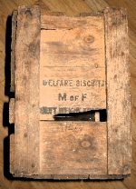
A crate from my collection that holds two tin cans with welfare biscuits which the Canadians drove into Holland with their trucks. Many people believe these this cans with buscuits were dropped by the bombers but that is not the case.
and the bulk of the supplies were still coming from Normandy and the channel ports. Resources in the recently liberated part of Holland were low and at that point it was not always possible to provide the Dutch and the troops together with a good ration of food.
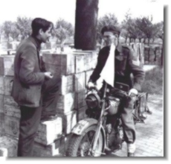
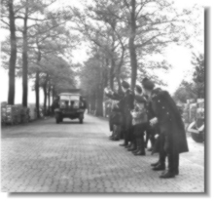
At the same point the alarming messages about an imminent food shortage were arriving in London. It was clear that more preparation was necessary to provide food for the people in Western Holland, at the moment that Western Holland would be liberated.
A committee in London set itself to the task to calculate what would be necessary to provide the Dutch people long enough from the moment that Western Holland would be liberated up to the moment that the seaport Rotterdam could be made operational.
The committee's report and persuasion from General Eisenhower led to the creation of food dumps in southern Holland by the 21st Army group under field marshal Montgomery. Food dumps were created near Den Bosh and Oss in the liberated south of the Netherlands. The dumps contained a total of 30.000 ton food.
Major General John GW Clark had been in charge of these food dumps and he had withstood the many requests to use the food in the dump for additional rations in the south he had brought the dumps back to 30 000 after the winter, when much of it had gone to Germany and Belgium. On May 2nd when operation Faust began, the dumps were fully stored and that mend that quick aid was indeed possible.
Operation Faust was to begin at precisely 07.00 on May 2nd as it had been negotiated by General Foulkes after negotiations with the Germans. It had been agreed that one thousand tons of food and medical supplies would be brought from Allied stock by truck through the German lines where it would be transported further by Dutch trucks. The Canadian 1st Corps had 12 platoons with each thirty trucks at their disposal for this task. four platoons where British and eight were canadian. The road would close every day at 18.00 so the trucks had to keep moving in order to unload all the stock before the deadline.
On May 2 The 49th Infantry Division was part of the 1st Canadian Corps and was stationed near Arnhem. Lt. John F Abbott was leading HQ platoon in the 482 Inf. Brig. Coy. Royal Army Signal Corps. He was ordered organize a convoy of 50 trucks and fill them with food. When the trucks were filled they went on their way to Wageningen. The trucks carried white flags, since they were going to cross the frontline. At Wageningen, Lt. Abbott saw Prince Bernhard and a German and an English general standing on the steps of, what appeared to be the town hall. The convoy proceeded its way towards the frontline. At the frontline the convoy ran into a group of Dutch SS-ers. These men acted very hostile. They threw bricks and stones at the convoy. The SS-ers were still armed, but no shots were fired.
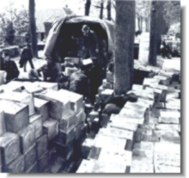
Dutch civilians were waiting to unload the trucks in Rhenen.
John Abbott: "I clearly remember that the few Dutch civilians who were send to unload our vehicles were so weary from starvation that they were unable to lift and carry the boxes. In the end we had to get some German troops to help. They were not very pleased and needed some persuasion!"
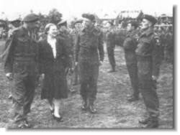
The 49th Infantry Division not only contributed to the aid for the Dutch by driving the trucks with food to Rhenen. When the Dutch Red Cross asked the men of the division for a donation, the division reacted with enthusiasm. The contribution of the individual members of the division was on average as high as one week's pay. The Dutch Red Cross spend its money among other things on the training and equipping of medical feeding teams, that were ready to help in Western Holland as soon as it was liberated.
Princess Juliana, chairman of the Dutch Red Cross got word of the donation made by the 49th division soldiers. She requested permission to visit the division after the war, to thank the men personally.

https://2ndworldwar.jimdo.com/collectie/voedselhulp-in-rond-de-hongerwinter/operatie-faust/
Vanuit opslagplaatsen bij o.a. Oss werden voorraden voedsel naar een neutraal gebied gebracht. Canadese en Engelse trucks brachten enorme hoeveelheden naar de Nude tussen Wageningen en Rhenen. Van hieruit werd het voedsel met andere vrachtwagens naar het hongerende westen van ons land getransporteerd.
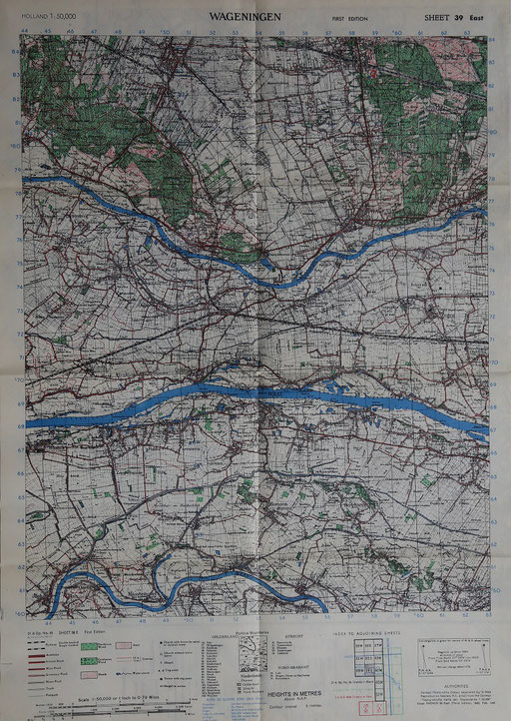

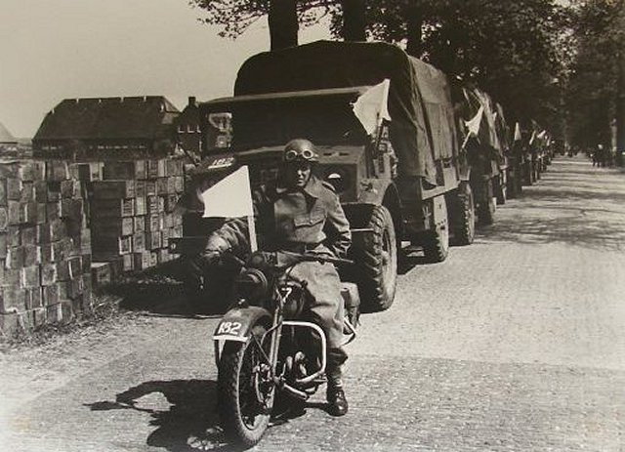
Nude 1945. Boerderij op de achtergrond staat er nog steeds 😊
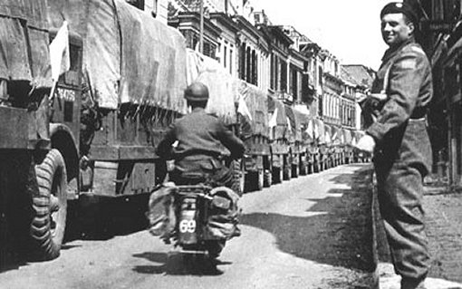
Canadees, Canadees, Canadees, ..en nog meer Canadezen

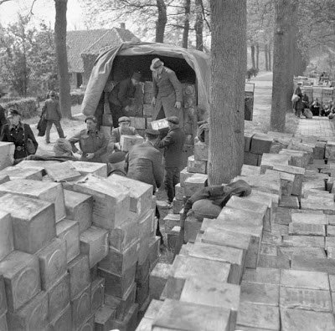

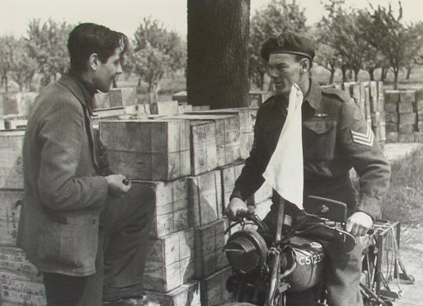

Operations Manna, Chowhound, and Faust
29 Apr 1945 - 10 May 1945
Contributor: C. Peter Chen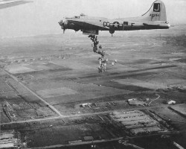

ww2dbaseAllied aircraft's targeting of all vehicular convoys, war damage to transportation infrastructure, cruelty of the German occupation, and the unusually harsh winter of 1944 to 1945 all contributed to great famine during the winter of 1944 to 1945 in the Netherlands. The suffering was particularly felt in the more densely populated western regions of the country. During the general Hongerwinter ("Hunger winter") period, approximately between Sep 1944 and May 1945, about 18,000 to 22,000 Dutch civilians died due to malnutrition and starvation, with Mar 1945 being the worst month by the number of deaths.
ww2dbaseIn Apr 1945, British Prime Minister Winston Churchill and US President Franklin Roosevelt agreed that something needed to be done. Shortly after, US Army Chief of Staff George Marshall gave Dwight Eisenhower the permission to conduct negotiations with Reichskommissar Arthur Seyß-Inquart of the German occupation for a limited ceasefire, through which relief could be brought to the civilians. Due to the negotiations, fighting was de-escalated from 28 Apr 1945 through what would become the end of the European War. It was then agreed that Allied aircraft bringing supplies for the civilians following specific air routes would not be fired upon by German anti-aircraft fire. The first of such missions took place on 29 Apr, and Seyß-Inquart would officially give the order to cease firing on Allied supply transports on 30 Apr.
ww2dbaseThe aerial Operation Manna commenced first on 29 Apr 1945, concluding on 7 May 1945. It was conducted by British, Australian, Canadian, New Zealand, and Polish aircraft and crews. During this operation, 3,301 sorties were flown (145 by Mosquito aircraft, 3,156 by Lancaster aircraft), delivering 6,680 tons of food and supplies. The crates were dropped without parachutes at the altitude of approximately 120 to 150 meters (about 400 to 500 feet) to Katwijk (Valkenburg airfield), The Hague (Duindigt horse race course and Ypenburg airfield), Rotterdam (Waalhaven airfield and Kralingse Plas), and Gouda.
ww2dbaseThe US aerial counterpart, Operation Chowhound, lasted from 1 May 1945 to 8 May 1945. A total of 2,268 sorties were flown by B-17 Flying Fortress bombers, delivering about 4,000 tons of food, some of which in the form of K-rations.
ww2dbaseThe third effort, Operation Faust, began at 0730 hours on 2 May 1945 and ended on 10 May 1945. During this operation, 360 Allied trucks (from 8 Canadian and 4 British transport platoons) conducted multiple round trips, delivering a total of about 9,000 tons of food and supplies to a designated area between the villages of Wageningen and Rhenen in central Netherlands. Logistical problems prevented Faust supplies from being distributed to the civilians in Amsterdam until 10 May 1945, in The Hague until 11 May 1945, and in Utrecht until 11 May 1945, however. While Operation Faust officially concluded on 10 May, 200 Canadian trucks remained on food distribution missions in the Netherlands for some time to come.
Operations Manna, Chowhound, and Faust Timeline
23 Apr 1945 | George Marshall authorized Dwight Eisenhower to negotiate with the Germans in the Netherlands for a limited ceasefire in order to bring relief to the starving civilians.
29 Apr 1945 | Two British RAF Lancaster bombers conducted the first Operation Manna sortie, delivering food to Dutch civilians.
30 Apr 1945 | Commissioner of the German occupation in the Netherlands, Arthur Seyß-Inquart, officially agreed that Allied aircraft delivering food and other supplies to Dutch civilians would not be harassed by German defensive fire.
1 May 1945 | US B-17 bombers dropped crates of K-rations over Amsterdam Schiphol Airport in the Netherlands.
2 May 1945 | At 0730 hours, the first of many Canadian and British trucks crossed German defensive lines in the Netherlands without being harassed to deliver food to Dutch civilians. On the same day, 400 US B-17 bombers dropped crates of K-rations over Amsterdam Schiphol Airport in the Netherlands.
3 May 1945 | US B-17 bombers dropped crates of K-rations over Amsterdam Schiphol Airport in the Netherlands.
5 May 1945 | 400 American B-17 bombers dropped food and other supplies over the Netherlands.
6 May 1945 | 400 American B-17 bombers dropped food and other supplies over the Netherlands.

Operations Manna and Chowhound
From Wikipedia, the free encyclopedia
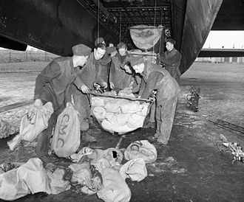
RAF ground crew loading food supplies into slings for hoisting into the bomb bay of an Avro Lancaster heavy bomber of 514 Squadron (1945).
Operation Manna and Operation Chowhound were humanitarian food drops, carried out to relieve a famine in German-occupied Holland, undertaken by Allied bomber crews during the final days of World War II in Europe.
Manna was carried out by British RAF units, as well as squadrons from the Australian, Canadian, New Zealand and Polish air forces, between 29 April and 7 May 1945.
Chowhound (1–8 May) was an operation by the U.S. Army Air Forces, which dropped, together with Operation Manna, a total of over 11,000 tons,^{[1]} of food into the still-unliberated western part of the Netherlands, with the acquiescence of the occupying German forces,^{[2]} to help feed Dutch civilians in danger of starvation.
After it was realised that Manna and Chowhound would be insufficient, a ground-based relief operation named Operation Faust was launched. On 2 May, 200 Allied trucks began delivering food to the city of Rhenen, behind German lines.
By early 1945, the situation was growing desperate for the three million or more Dutch still under German control. Prince Bernhard appealed directly to Allied Supreme Commander Dwight D. Eisenhower, but Eisenhower did not have the authority to negotiate a truce with the Germans. While the prince got permission from British Prime Minister Winston Churchill and U.S. President Franklin D. Roosevelt, Eisenhower had Air Commodore Andrew Geddes begin planning immediately. On 23 April, authorisation was given by the Chief of Staff, George Marshall.
Allied agents negotiated with Reichskommissar Arthur Seyss-Inquart and a team of German officers. Among the participants were the Canadian future writer Farley Mowat and the German commander-in-chief, General Johannes Blaskowitz. It was agreed that the participating aircraft would not be fired upon within specified air corridors.
The British operation started first. It was named after the food which was miraculously provided to the Israelites in the Book of Exodus. The planning of the operation was initially done by the Royal Air Force.^{[3]}
The first of the two RAF Avro Lancasters chosen for the test flight, the morning of 29 April 1945, was nicknamed Bad Penny, as in the expression: "a bad penny always turns up".^{[4]} This bomber, with a crew of seven young men (five from Ontario, Canada, including pilot Robert Upcott of Windsor, Ontario), took off in bad weather despite the fact that the Germans had not yet agreed to a ceasefire. (Seyss-Inquart would do so the next day.) Bad Penny had to fly low, down to 50 feet (15 m), over German guns, but succeeded in dropping her cargo and returning to her airfield.
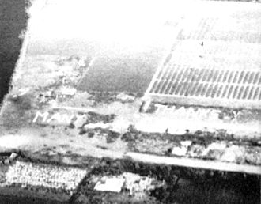
Many Thanks spelt-out on the ground in tulips after Operation Manna
Operation Manna then began in earnest.^{[5]} British aircraft from Groups 1, 3, and 8 took part, flying 145 sorties by Mosquitoes and 3,156 sorties by Lancaster bombers, flying between them a total of 3,301 sorties.
These bombers were used to dropping bombs from 6,000 metres (20,000 ft), but this time they had to do their job from a height of 150 metres (490 ft), some even flying as low as 120 metres (390 ft), as the cargo did not have parachutes.^{[6]} The drop zones, marked by Mosquitoes from 105 and 109 Squadrons using Oboe, were: Katwijk (Valkenburg airfield), The Hague (Duindigt horse race course and Ypenburg airfield), Rotterdam (Waalhaven airfield and Kralingse Plas (nl)) and Gouda. Bomber Command delivered a total 6,680 tons of food.
John Funnell, a navigator on the operation, says the food dropped was tinned food, dried food and chocolate.
As we arrived people had gathered already and were waving flags, making signs, etc., doing whatever they could. It was a marvellous sight. As time went on, so there were also messages, such as Thank you for coming boys. On the 24th April, we were on battle order at Elsham Wolds. We went to a briefing and were told the operation was cancelled because Bomber Harris thought it was too dangerous for the crews. The idea was we would cross the Dutch border at 1,000 feet, and then drop down to 500 feet at 90 knots which was just above stalling speed. On the 29th, we were on battle orders again. There was no truce at that point, and as we crossed the coast, we could see the anti-aircraft guns following us about. We were then meant to rise up to 1,000 feet, but because of the anti-aircraft guns we went down to rooftop level. By the time they sighted on us, we were out of sight. A lot of people were surprised we went without armaments, in case of any trigger-happy tail gunner. Originally, it was going to be 'Operation Spam' which was in my log book. We also went to Lyden, but dropped the food at Falkenburg. We navigators are interested in the latitude and longitude of the place, rather than the name.
The idea was for people to gather and redistribute the food, but some could not resist eating straight away, which caused some people to get sick and vomit, (and some died) a result that fatty food can have in starved bodies known as Refeeding syndrome. On the other hand, distribution sometimes took as long as ten days, resulting in some getting the food only after the liberation. Nevertheless, many lives were saved, and it gave hope and the feeling that the war would soon be over.
Earlier, there had been a distribution of white bread made from Swedish flour that was shipped in and baked locally. A popular myth holds that this bread was dropped from aircraft, but that is a mix-up between the two events. Also, the food was not dropped with parachutes, as is often said.

Operation Faust
THE WAGENINGEN - RHENEN TRUCKEXPRESS
At the meeting in Achterveld on April 30 both sides decided that the transport by air alone would not suffice. A second operation, codenamed Faust, would also be launched. Two hundred allied trucks from the 21st Army Group would bring food to Rhenen, starting May 2nd. Rhenen was at that moment a city on the German side of the frontline. In Rhenen the trucks would go over in the hands of Dutch truck drivers, who would take the food further into occupied Holland. According to the plan, 1000 tons of food would be transported daily by the Wageningen - Rhenen road.
Where did all this food come from? Did the Allies have huge supplies directly behind their lines? To answer this question we have to go back to October 1944. The southern part of the Netherlands had recently been liberated and the frontline had stabilized when the airborne operation Market Garden had failed. The liberation of the south of the Netherlands had faced the Allies with some logistic problems. The port of Antwerp was still not used because the Germans still held Walcheren.
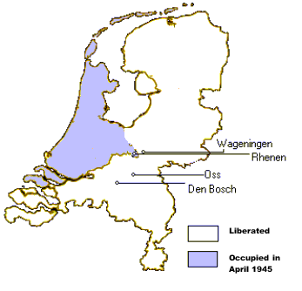
Map of Holland. The food came from food dumps in Oss and Den Bosch and was transported to Rhenen through Wageningen.

Operation Faust
THE WAGENINGEN - RHENEN TRUCKEXPRESS
At the meeting in Achterveld on April 30 both sides decided that the transport by air alone would not suffice. A second operation, codenamed Faust, would also be launched. Two hundred allied trucks from the 21st Army Group would bring food to Rhenen, starting May 2nd. Rhenen was at that moment a city on the German side of the frontline. In Rhenen the trucks would go over in the hands of Dutch truck drivers, who would take the food further into occupied Holland. According to the plan, 1000 tons of food would be transported daily by the Wageningen - Rhenen road.
Where did all this food come from? Did the Allies have huge supplies directly behind their lines? To answer this question we have to go back to October 1944. The southern part of the Netherlands had recently been liberated and the frontline had stabilized when the airborne operation Market Garden had failed. The liberation of the south of the Netherlands had faced the Allies with some logistic problems. The port of Antwerp was still not used because the Germans still held Walcheren.
Map of Holland. The food came from food dumps in Oss and Den Bosch and was transported to Rhenen through Wageningen.
- Unloading food along the Rhenen Wageningen road. Source Canadian National Archives
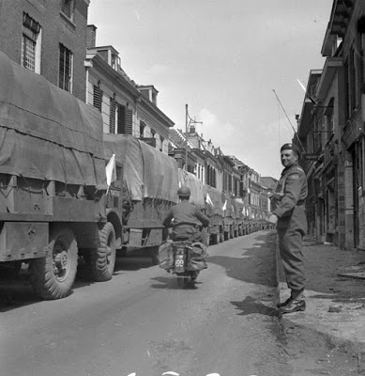Food trucks in Wageningen. Source Canadian National Archives
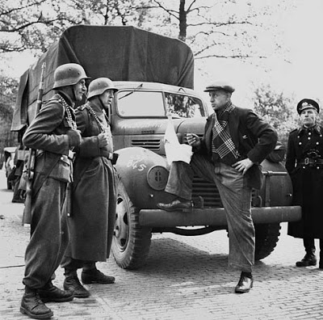German guards talking to a Dutch lorry driver. Source: Canadian National Archives
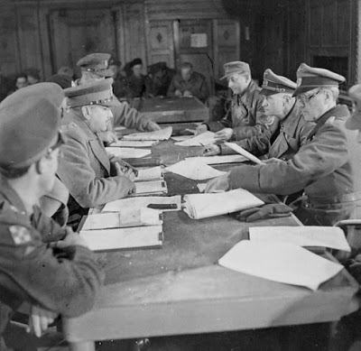Negotiations between the Allies and Germans in Hotel De Wereld in Wageningen. Source: Canadian National Archives
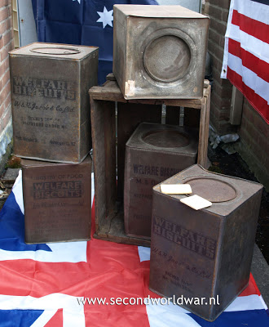A large portion of the food in the trucks came in these biscuit cans. Collection:
- 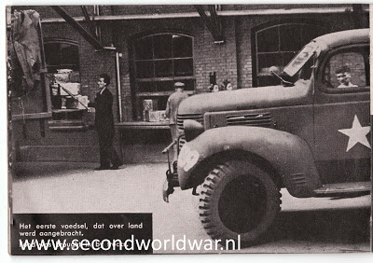Food trucks in The Hague
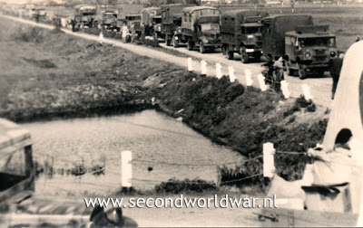Canadian trucks arriving at Terbregge. Photo Courtesy: Henk Kleinsmit
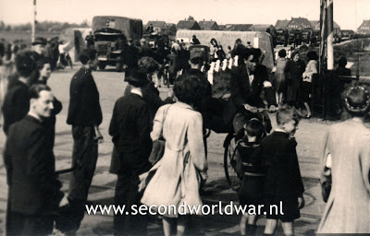Canadian trucks arriving at Terbregge. Photo Courtesy: Henk Kleinsmit

Extract from the book On to Victory from Mark Zuehlke:
Captain Robert H. Parkinson's platoon from 1st Canadian Armoured Brigad, Royal Canadian Army Service Courps, was first to enter hte German lines. Each truck had a white flag mounted on the front fender, but the drivers all had a weapon discreetly hidden in the cab and were under instructions not to get out of the truck for any reason. "We knew we were taking food to the Dutch people. It was interesting and somewhat scary as we passed German soldiers who were fully armed and probably the were as interested or frightened as we were... We offloaded the food at the side of the road and turned it over to some kind of Dutch authorities... They took charge of the food and we didn't at any time have ... contact with the Germans." The twelve platoons continued moving food into Holland even after the war ended, delivering the last thousand-ton allotment on May 10.

Friesch Daglad Friday 4 May 1945
Richly loaded trucks drive into Holland - Prelude to Victory
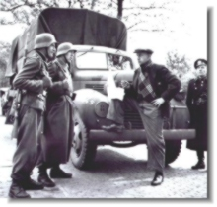
English and American bombers have again dropped another 2700 tons of food over occupied Holland since Wednesday. The ships that carry food will from this moment on go directly to Amsterdam. Trucks are now bringing in supplies as well. A place has been assigned within the German lines, where every truck can drop off ten tons of supplies. Every convoy is accompanied by a jeep carrying a white flag. Canadian MP's were posted on several places while further up the road German SS-men were posted. The convoy were greeted by cheering crowds: Dutch people helped to unload the trucks. It was clearly noticeable that the hunger had weakened the people. Some took the liberty to taste a biscuit in advance. The transport-system worked smoothly. Dutch policemen were present at the supply dumps. The Canadian Army has provided 200 trucks for the transport of the food to the different places. The river ships will also be called upon for aid. The Germans have agreed to make the rivers accessible again. Food from Switzerland will be brought through the Zuiderzee directly to Amsterdam. The transport though the air can provide 30 million rations.
The New York Tribune writes that the remarkable agreement on which the port of Rotterdam and certain roads have been opened, might be a sign that the end of German occupation is coming near.

Dutch famine of 1944–45
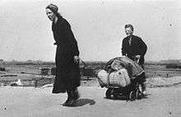
Two dutch women during the famine period.
The Dutch famine of 1944–45, known as the Hongerwinter ("Hunger winter") in Dutch, was a famine that took place in the German-occupied part of the Netherlands, especially in the densely populated western provinces north of the great rivers, during the winter of 1944–45, near the end of World War II. A German blockade cut off food and fuel shipments from farm areas. Some 4.5 million were affected and survived because of soup kitchens. As many as 22,000 may have died because of the famine;^{[1]} one author estimated 18,000.^{[2]} Loe de Jong (1914–2005), author of The Kingdom of the Netherlands During World War II, estimated at least 22,000 deaths.^{[3]} Most of the victims were reported to be elderly men.^{[4][5]}
The famine was alleviated by the liberation of the area by the Allies in May 1945. Prior to that, bread baked from flour shipped in from Sweden, and the airlift of food by the Royal Air Force, the Royal Canadian Air Force, and the U.S. Army Air Forces – under an agreement with the Germans that if the Germans did not shoot at the mercy flights, the Allies would not bomb the German positions – helped to mitigate the famine. These were Operations Manna and Chowhound. Operation Faust also trucked in food to the area.

Causes
See also: History of the Netherlands (1939–1945)
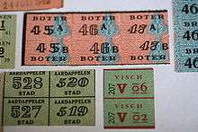
Dutch food ration coupons from World War II
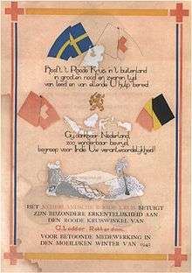
A letter of commemoration given to a grocer whose shop served as a Red Cross point giving out the "Swedish bread"
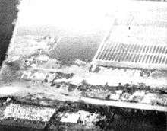
Operation Manna – "Many Thanks" written in tulips, Holland, May 1945.
Towards the end of World War II, food supplies became increasingly scarce in the Netherlands. After the landing of the Allied Forces on D-Day, conditions grew increasingly worse in the Nazi-occupied Netherlands. The Allies were able to liberate the southern part of the country, but their liberation efforts came to an abrupt halt when Operation Market Garden, their attempt to gain control of the bridge across the Rhine at Arnhem, failed. The seizure of the approaches to the port of Antwerp (the Battle of the Scheldt) was delayed due to Montgomery's preoccupation with Market Garden.
After the national railways complied with the exiled Dutch government's appeal for a railway strike starting September 1944 to further the Allied liberation efforts, the German administration (under Wehrmachtbefehlshaber Friedrich Christiansen) retaliated by placing an embargo on all food transports to the western Netherlands.
By the time the embargo was partially lifted in early November 1944, allowing restricted food transports over water, the unusually early and harsh winter had already set in. The canals froze over and became impassable for barges.

Food
Food stocks in the cities in the western Netherlands rapidly ran out. The adult rations in cities such as Amsterdam dropped to below 1000 kilocalories (4,200 kilojoules) a day by the end of November 1944 and to 580 kilocalories in the west by the end of February 1945.^{[6]} Over this Hongerwinter ("Hunger winter"), a number of factors combined to cause starvation in especially the large cities in the West of the Netherlands: the winter in the month of January 1945 itself was unusually harsh prohibiting transport by boat for roughly a month between early January 1945 and early February 1945, also the German army destroyed docks and bridges to flood the country and impede the Allied advance and thirdly the Allied bombardments made it extremely difficult to transport food in bulk since they were not able the make distinctions between military and civilian transports. As the south-eastern (the Maas-valley) and the south-western part of the Netherlands (Walcheren and Beveland) became one of the main western battlefields, this three reasons combined to make the transport of existing food stocks in large enough quantities nearly impossible.
The areas affected were home to 4.5 million people. Butter disappeared after October 1944, shortly after railwaytransport to the western parts of the Netherlands had stopped in September due to the railwaystrike. The supply of vegetable fats dwindled to a minuscule seven-month supply of 1.3 liters per person. At first 100 grams of cheese were allotted every two weeks; the meat coupons became worthless. The bread ration had already dropped from 2,200 to 1,800 and then to 1,400 grams per week. Then it fell to 1,000 grams in October, and by April 1945 to 400 grams a week. Together with one kilogram of potatoes, this then formed the entire weekly ration. The black market increasingly ran out of food as well, and with the gas and electricity and heat turned off, everyone was very cold and very hungry.^{[7]} In search of food, young strong people would walk for tens of kilometers to trade valuables for food at farms. Tulip bulbs and sugarbeets were commonly consumed. Furniture and houses were dismantled to provide fuel for heating.
In the last months of 1944 in anticipation of the coming famine tens of thousands of children were brought from the cities to rural areas where many remained until the end of the war. The dying in the three big cities in the Western Netherlands (The Hague, Rotterdam and Amsterdam) started in earnest in December 1944, reaching a top in March 1945,^{[8]} but remained very high in April and May 1945. In early summer 1945 the famine was brought quickly under control. From September 1944 until May 1945 the deaths of 18,000 Dutch people were attributed to malnutrition as the primary cause and in many more as a contributing factor.^{[6]}

End of the famine
The Dutch Famine ended with the liberation by the Allies of the western Netherlands in May 1945. Shortly before that, some relief had come from "Swedish bread", which was baked in the Netherlands from flour shipped in from Sweden. Shortly after these shipments, the German occupiers allowed coordinated air drops of food over German-occupied Dutch territory by the Royal Air Force and Royal Canadian Air Force from 29 April to 7 May, and by the U.S. Army Air Forces from 1 to 8 May. This was Operation Manna (RAF/RCAF) and Operation Chowhound (USAAF). The Germans agreed to not shoot at the planes flying the mercy missions, and the Allies agreed not to bomb German positions. Operation Faust also trucked in food to Rhenen beginning on 2 May, utilizing 200 vehicles. Rhenen was also occupied by the Germans.

Legacy
The Dutch famine of 1944–45 was a rare case of a famine which took place in a modern, developed, and literate country, albeit one suffering under the privations of occupation and war. The well-documented experience has helped scientists to measure the effects of famine on human health.
The Dutch Famine Birth Cohort Study, carried out by the departments of Clinical Epidemiology and Biostatistics, Gynecology and Obstetrics and Internal Medicine of the Academic Medical Centre in Amsterdam, in collaboration with the MRC Environmental Epidemiology Unit of the University of Southampton in Britain, found that the children of pregnant women exposed to famine were more susceptible to diabetes, obesity, cardiovascular disease, microalbuminuria and other health problems.^{[9]}
Moreover, the children of the women who were pregnant during the famine were smaller, as expected. However, surprisingly, when these children grew up and had children those children were thought to also be smaller than average.^{[10]} These data suggested that the famine experienced by the mothers caused some kind of epigenetic changes that were passed down to the next generation. Despite this, a subsequent study by the same author failed to find a correlation between maternal exposure to famine and birth weight of the next generation.^{[11]}
The discovery of the cause of coeliac disease may also be partly attributed to the Dutch famine. With wheat in very short supply there was an improvement at a children's ward of coeliac patients. Stories tell of the first precious supplies of bread being given specifically to the (no longer) sick children, prompting an immediate relapse. Thus in the 1940s the Dutch paediatrician Dr. Willem Dicke^{[12]} was able to corroborate his previously researched hypothesis that wheat intake was aggravating coeliac disease.^{[13]} Later Dicke went on to prove his theory.
Audrey Hepburn spent her childhood in the Netherlands during the famine and despite her later wealth she had lifelong negative medical repercussions. She suffered from anemia, respiratory illnesses, and œdema as a result.^{[14]}
Subsequent academic research on the children who were affected in the second trimester of their mother's pregnancy found an increased incidence of schizophrenia in these children.^{[15]} Also increased among them were the rates of schizotypal personality and neurological defects.^{[16]}

