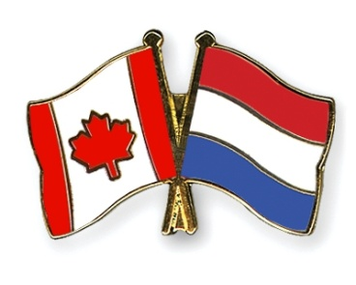

**15 February, 2018**

**OPERATION MANNA AND FAUST REVISITED 2020**

**LOGISTICS BRANCH MEMORIAL AND CELEBRATION**

**Overview**

Some Dutch friends of mine are looking into the possibility of conducting a “re-enactment” of Operations MANNA and FAUST in 2020 – the 75th Anniversary. Op MANNA and FAUST were the food relief operations in The Netherlands in spring 1945 (April-May) – where Canada played a major role saving the lives of thousands of starving Dutch citizens. This would be an opportunity for the Log Branch to put on a show in the days leading up to the 75th Anniversary of the Liberation of Holland. As the Log Branch they could celebrate past accomplishments and enhance their profile (remembering, recognizing and celebrating the planners and leaders Manna and Faust, RCASC truckers, Ordnance Corps suppliers, Food Services, RCAF Air Log/Air Drop, etc – plus RCEME, Sigs, Medics, MPs, etc). It would be good for the Logistics Branch and good for Canada.

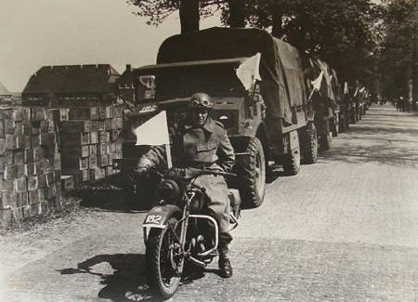[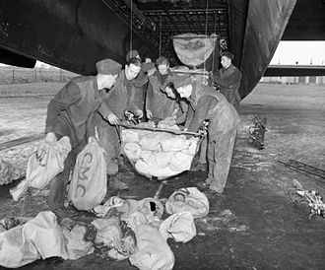](https://en.wikipedia.org/wiki/File:Loading_Lancaster_at_RAF_Waterbeach_for_Operation_Manna_1945_IWM_CH_15159.jpg)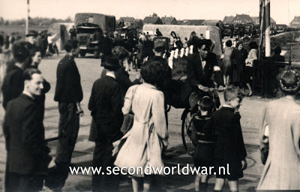

See: Food to Northern Holland – Start at 8 Min 43 Sec: <https://www.youtube.com/watch?v=9w0N-S_MJQc>

See: Veterans Remember / Les anciens combattants se souviennent - Start at 2 Min, 15 Sec:

<https://youtu.be/3yfDXOupDcU>

The group planning this 2020 event in The Netherlands are associated with “Keep Them Rolling” (Dutch re-enactors), and they organized “The Final Push” in 2015, in which over 300 WWII vehicles and several hundreds of re-enactors with tanks, guns, jeeps, etc, over a period of ten-12 days followed the liberation of Holland route from the Greosbeek to the Reichwald/Hochwald, crossing the Rhine and on to Groningen, on the actual route and same days of the Canadian Army’s final push north in 1945. It was an incredible and very meaningful event with celebrations in each town and village on their Liberation Day. 7th Toronto Regiment, RCA, took a dozen Gunners on this trip, riding on the guns and trucks of KTR, and the Canadian soldiers learned much (Battlefield studies) and greatly enjoyed the experience.

The reason for approaching the Logistics Branch is to see if they would like to be “front and centre” in this event, Op Manna & Faust re-enactment – and, planning would have to start soon. The key organizer for the “Final Push” in 2015 and for this possible upcoming event is a successful Dutch businessman whose family survived because of Canadians delivering food at this critical time. He is prepared to fly to Canada to begin discussions on potential Canadian participation.

Meanwhile, the Log Branch may wish to research Operations Manna and Faust – e.g., where the planning took place, routes the trucks followed, supply and distribution points, stats on supplies, units, and so on. One can locate info on various websites, but it is sketchy – tanks, guns and infantry get more fanfare, more coverage.

The Log Branch might wish to discuss this with the Senior Serving Logistician and Colonel Commandant to see if the Log Branch (and related air and other support) might be interested in a participating in a non-public sense. No doubt DND/CAF, Global Affairs Canada and VAC would be interested, as would the Dutch-Canadian community. This could be a great opportunity for Canada to reinforce our significant efforts in Europe 75 years ago, and a reminder as to why “Canada is back.” Also, this would be a great opportunity to build cohesion, morale, esprit de corps, professional knowledge (studies on logistics from Normandy, Antwerp, crossing the Rhine, etc), networking and financial health in the Log Branch and Log Association.

**The Plan/Planning Process**

Having assembled all one can gather off the net – this is clearly a story that involves Canada in a major humanitarian effort in the middle of fighting at the end of the war – what a story! The GOC will love it, as will the people in The Netherlands and Dutch people who came to live in Canada. This would unite the Log Branch, raise morale, raise money for the Logistics Association/Foundation, and raise the profile of the Log Branch on the tail end of the 50th Anniversary.

However, first and foremost one must complete a **Mission Analysis**. What might the Branch wish to achieve:

* Promote the image of the Logistics Branch
* Enhance Cohesion, Morale, Esprit de Corps of the Branch and within the Branch
* Professional studies in Logistics for Junior serving personnel
* Historical studies and analysis
* Commemorate and celebrate the past and those who served and died 75 years earlier
* Recognize and reward (with a trip) deserving sailors, soldiers and aircrew of the Log Branch
* Cement Canada-Netherlands relations
* Build and enhance the Association
* Raise funds for the Association
* Create ties to communities across Canada while fundraising (especially with Reserve units)
* Create ties to businesses, suppliers and prominent Canadians across Canada while fundraising
* By extension, promote the image of Canada as a war fighting AND humanitarian nation
* Remember and celebrate relations between Canadian service personnel and the Dutch people and communities
* Give the Dutch diaspora in Canada an opportunity to thanks their Canadian Armed Forces
* Etc
* Etc
* All of the above? Some of the above?

One could visualize 100 (or more) Logistics personnel (and others, e.g., medics, RCEME, aircrew). One could engage all log units/outfits at bases, stations, ships, etc Regular Force and Reserve, across Canada. Log Pers could be riding on Keep Them Rolling vehicles on the same routes from the same supply depots as were used 75 years ago, with Ceremonies at the start and end, and at every town and village along the way. One could invite retired members of Log Branch on the trip (last year the RCA had 100 Gunners and 100 Sigs, serving and retired on a commemoration/battlefield study tour to Normandy and Vimy).

The Op MANNA/FAUST events would start a bit before 1-2 May 2020 and wrap up in time for the troops to participate in or at least attend the major ceremonies of 5 May (Liberation Day). The 5 May Official Ceremonies at Wagenengen NL will be separate ceremonies organized by VAC, probably with a 100 person guard, band, VIPs, etc, etc. The Log Branch would be better off running their activity as a non-public/arms length program (however, requesting some DND support, such as Hercs, field kitchens, vintage vehicles, authority to wear uniform, etc).

This would be an opportunity to showpiece the following: Service Corps, Trucks, Mechanics, Ordinance Corps, Cooks/Food services, MPs/Provost Corps, Medics, Pilots Navs Flight Crews, and so on, plus combat arms if wished. Airlift and air dropping of supplies, such as candies or paper poppies or flags (a couple of Hercs), and setting up field kitchens giving out hot dogs/hamburgers at ceremonies. Buglers, Pipers and Drummers with all ceremonies.

The Logistics contingent should include organized Battlefield Studies (Logistics from Normandy to the front, and Antwerp to the front line, and Crossing the Rhine, etc, etc). Engage professional historians to manage the Professional Development aspects – Battlefield Studies. Examples of Historians – Col John Conrad, Jack Granatstein, Marc Milner, Lee Windsor, BGen Dave Patterson.

Fundraising across Canada (Dutch diaspora and the many suppliers to DND and DND Bases) to support sending 100 service personnel ($3.5-4K each) and there would be money left over to support the Log Association, and support the Log/Ordinance Museum.

Complete all of the above with funds raised by the Association and by individual units across Canada. Do not rely on DND or VAC, or Heritage Canada – but do not be shy to ask all of them for financial and other support. But, undertake this as a private, at-arms-length initiative (except for loan of equipment and use of Hercs)

Recommend the development of an Estimate of the Situation and the key elements of the Op Planning Process, to include:

* Background
* Mission Analysis
* Situation
* Mission
* Concept of Operation
* Execution
* Lines of Operation
* Admin and Log
* Command, Coord, Communications
* Specifics on:
  + Site Visit/Recce
  + Milestones
  + Coord/coop with Keep Them Rolling
  + Coord/Coop with DND and VAC
  + Coord/Coop with Cdn Embassy NL
  + Coord/Coop with NL Forces
  + Battlefield Studies
  + Comms and PA
  + Financial Estimates and Budgeting
  + Fundraising Concept
  + Ceremonies
  + Etc

Meanwhile, it would be interesting and useful if the Log Branch assembled a single document overview of Op Manna and Faust, particularly the Canadian aspects. Maybe get John Conrad to write it. This would be a good book to sell in 2020.

It is highly recommend that the Logistics Branch/Association assemble a planning team of serving and retired folks, soon.

I would be most pleased to brief the Log Branch Association Board/Senate with a view to generating interest in this undertaking and if it were a “go” to assist in initiating the planning and project concept.



**Ernie Beno**

Ernest B. Beno, OMM, CD

Brigadier-General, Retired

1066 Caitlin Crescent

Kingston, Ontario, Canada

K7P 2S4

Phone: 613-389-6940

Mobile: 613-530-0694

E-mail: [beno@kos.net](mailto:beno@kos.net)