Apprentices
“The Soldier Apprentice Training Program of the Canadian Army was a program designed to raise the educational level of various corps of the Canadian army after World War II and the Korean War and to graduate highly trained soldiers for future employment as non-commissioned officers NCOs and senior NCOs. This was necessary because of the lack of educational training of many of the soldiers who decided to remain in the services after these two conflicts; many of these had joined the military at a young age and in many cases had not finished their education in the rush to help defend freedom in the world at that time.
With the above in mind, a program was designed and implemented where young men between the ages of 16 and 17 (no younger and no older) were recruited into a seven-year program of which the first two years were a combination of military training, trades training, and additional schooling. A half day of military and a half day of scholastic training were involved during most of this two-year time frame. A graduate after this two-year period usually had increased his educational level by two grades and was also trades trained to the Group 1 level in his chosen trade. Upon graduating after two years of intensive training, the apprentices were assigned to various military units and still had five years to serve with their option of taking their release after three years. Thus it was a minimum term of five years before one could officially take his release.” From Wikipedia, the free encyclopedia
Although initially designed to train soldiers for employment in non-commissioned ranks, as the program evolved it became common for graduates to continue on through various commissioning plans.
Former Apprentices are active today in maintaining contact through associations and reunions. RCASC Apprentices maintain an Association; the website is at http://www.rcasc.org/apprentice.html
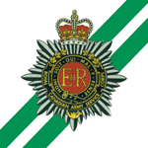

An RCOC Apprentice Reunion was recently held in Kingston in July 2014, for former RCOC “Green Monsters”. The Rogues’ Gallery appears below.
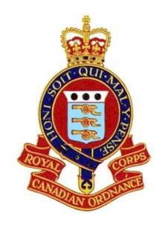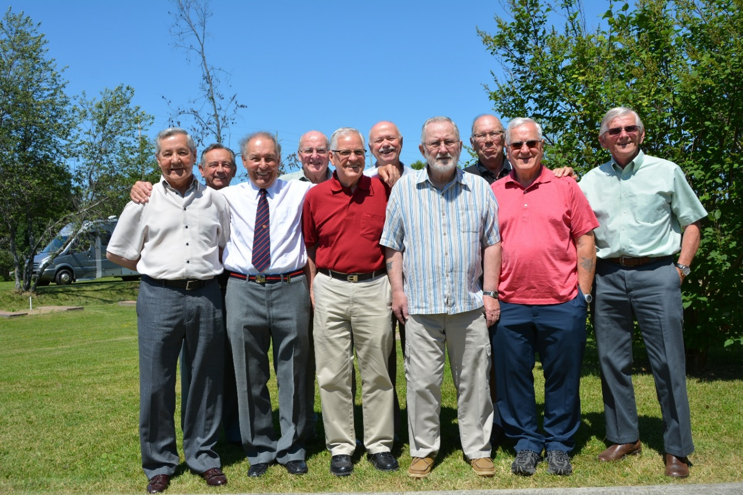
RCOC Apprentice Soldiers: Platoon / Year, From Left to Right
0354 Marty Young, 0354 Butch McPherson, 0253 Stan Jackson,
0253 Joe Boseley, 0455 Neil Cameron, 0253 Carl Duff,
0354 Jim Steed, 0153 Lorne Wells, 0253 René Kelly, 0354 Bob Elliott

