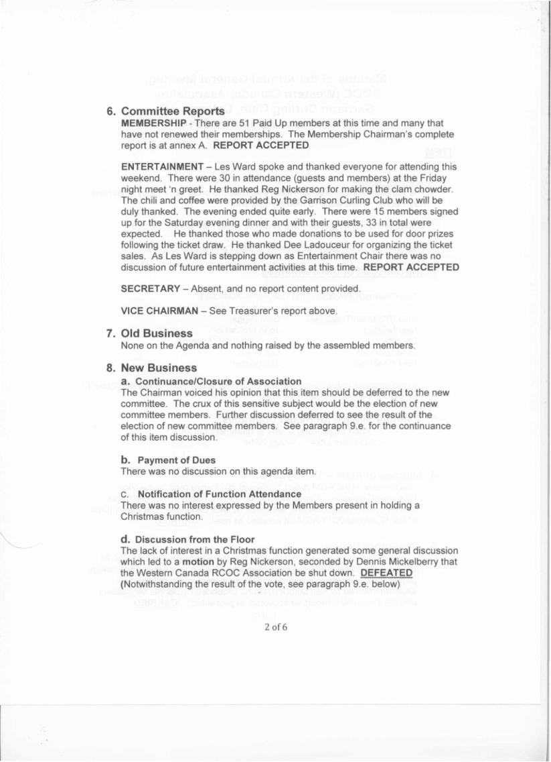



**Minutes**  **of the Annual**  **General**  **Meeting**  **RCOC (Western**  **Canada)**  **Association**

**Garrison**  **Curling**  **Club, Calgary,**  **AB**  **1700 hours, August**  **16, 2014**

**1. Call To Order**

The Annual General Meeting (AGM) was called to order at 17:02 by Chairman Ray Penny. There were 15 members present

Copies of the AGM Agenda were available for all members to peruse.

The Chairman then asked all present to stand and sing 0 Canada.

2. **Introduction of the Committee**

The Chairman introduced the Committee Members:

Vice ChairmanlTreasurer Membership

Secretary Entertainment

Past Chairman

Glen Higgs John McCallum

Ron Motteram (Absent) Les Ward

Joe Ganter

In the absence of the Secretary, the Chairman asked the Membership Chair to be the Acting Secretary for this AGM.

**3. 1 Minute Silence for Fallen Comrades**

- Gilbert Lloyd Perry - rank at retirement not known

- WO Norm Litke

- July 2014

**4. Minutes of AGM -17**  **August 2013**

The minutes of the AGM dated 17 August 2013 were read by the Vice ChairmanlTreasurer. There being no errors or omissions reported it was

moved by Reg Nickerson and seconded by Dick Ladouceur that the minutes of the 17 August 2013 AGM be adopted as read. **CARRIED**

**5. Treasurers Report**

The Vice ChairmanlTreasurer reported that the Association had $5,858.04 dollars in the bank, $26.91 in petty cash and $6.42 in postage stamps before

paying for this weekend's reunion and that we were in a good financial situation. Moved by Ken MacD0naid and seconded by Dennis Mickelberry

that the Treasurer's report be accepted as presented. 10f6

**CARRIED**

expected.

20f6



**6. Committee Reports**

**MEMBERSHIP**  **-** There are 51 Paid Up members at this time and many that have not renewed their memberships. The Membership Chairman's complete

report is at annex A. **REPORT ACCEPTED**

**ENTERTAINMENT**  **-** Les Ward spoke and thanked everyone for attending this weekend. There were 30 in attendance (guests and members) at the Friday

night meet 'n greet. He thanked Reg Nickerson for making the clam chowder. The chili and coffee were provided by the Garrison Curling Club who will be

duly thanked. The evening ended quite early. There were 15 members signed up for the Saturday evening dinner and with their guests, 33 in total were

He thanked those who made donations to be used for door prizes following the ticket draw. He thanked Dee Ladouceur for organizing the ticket

sales. As Les Ward is stepping down as Entertainment Chair there was no discussion of future entertainment activities at this time. **REPORT ACCEPTED**

**SECRETARY -** Absent, and no report content provided.

**VICE CHAIRMAN -** See Treasurer's report above.

7. **Old Business**

None on the Agenda and nothing raised by the assembled members.

**8. New Business**

**a. Continuance/Closure**  **of Association**

The Chairman voiced his opinion that this item should be deferred to the new committee. The crux of this sensitive subject would be the election of new

committee members. Further discussion deferred to see the result of the election of new committee members. See paragraph 9.e. for the continuance

of this item discussion.

**b.**  **Payment of Dues**

There was no discussion on this agenda item.

C. **Notification of Function Attendance**

There was no interest expressed by the Members present in holding a Christmas function.

**d. Discussion from the Floor**

The lack of interest in a Christmas function generated some general discussion which led to a **motion** by Reg Nickerson, seconded by Dennis Mickelberry that

the Western Canada RCOC Association be shut down. **DEFEATED**  (Notwithstanding the result of the vote, see paragraph 9.e. below)

30f6



9. Election of Committee for 2015

a. Chairman - In the April mail-out to Association members to renew their

membership it was made very clear that the current Chairman, after 3 years in the chair, would be stepping down this year. The Chairman called for

nominations/volunteers to replace the Chairman position on the committee. There was no nomination or volunteer forthcoming.

b. Entertainment Chair - The Chairman called for nominations/volunteers

to replace the Entertainment Chair position on the committee. There was no nomination or volunteer forthcoming.

c. Secretary - The Chairman called for nominations/volunteers to replace

the Secretary position on the committee. Initially, as per the two previous vacant position calls, there was no response. After some deliberation

between the Chairman and the Past Chairman Joe Ganter, Joe volunteered to become the new Secretary if Ray Penny would stay on as Chairman.

Though Ray Penny wavered for a short period of time he reaffirmed that he was stepping down. There were no objections to Joe Ganter becoming the

new Secretary.

d. The Past Chairman, Joe Ganter, asked why the Vice Chairman was not

moving up into the Chairman's position as had been the Association's past practice. The Vice Chairman answered that as he was also the Treasurer

such a move would be costly to change all the banking records and signing authorities as was just done one year ago, and then it would be necessary

to elect a new Treasurer, since it would be a conflict for the Chairman to also be the Treasurer. The lack of nominations/volunteers for two of the

three currently, to be vacated positions, did not bode well for electing a new Treasurer.

e. Decision - Without structure formal organizations cannot properly function. As there was a failure to elect replacements

for the Chairman and the Entertainment Chair, the Chairman declared that the Western Canada RCOC Association would

stand down as a formal organization post-haste. Notwithstanding the earlier motion and vote recorded at

paragraph 8.d., the stand down decision was not challenged by any member present. CARRIED

10. Disposition of Association Assets

With the decision taken to stand down the Western Canada RCOC Association there was a need for some discussion on how to dispose of the Association's assets - cash and material. To generate some discussion the Vice Chairman/

Treasurer voiced a suggestion that, as an example, after all fiscal liabilities were cleared and any loaned material assets returned to their rightful owner,

*oJ*

11_Adjournment

then the remaining assets could be divided three ways and offered to the

RCOC Museum, the Calgary Military Museum and the Western Canada branch of the Last Post Fund. (Information on this fund may be read at

<http://www.lastpostfund.ca/EN/home.php>)

.,

,

~

\

."

.

40f6

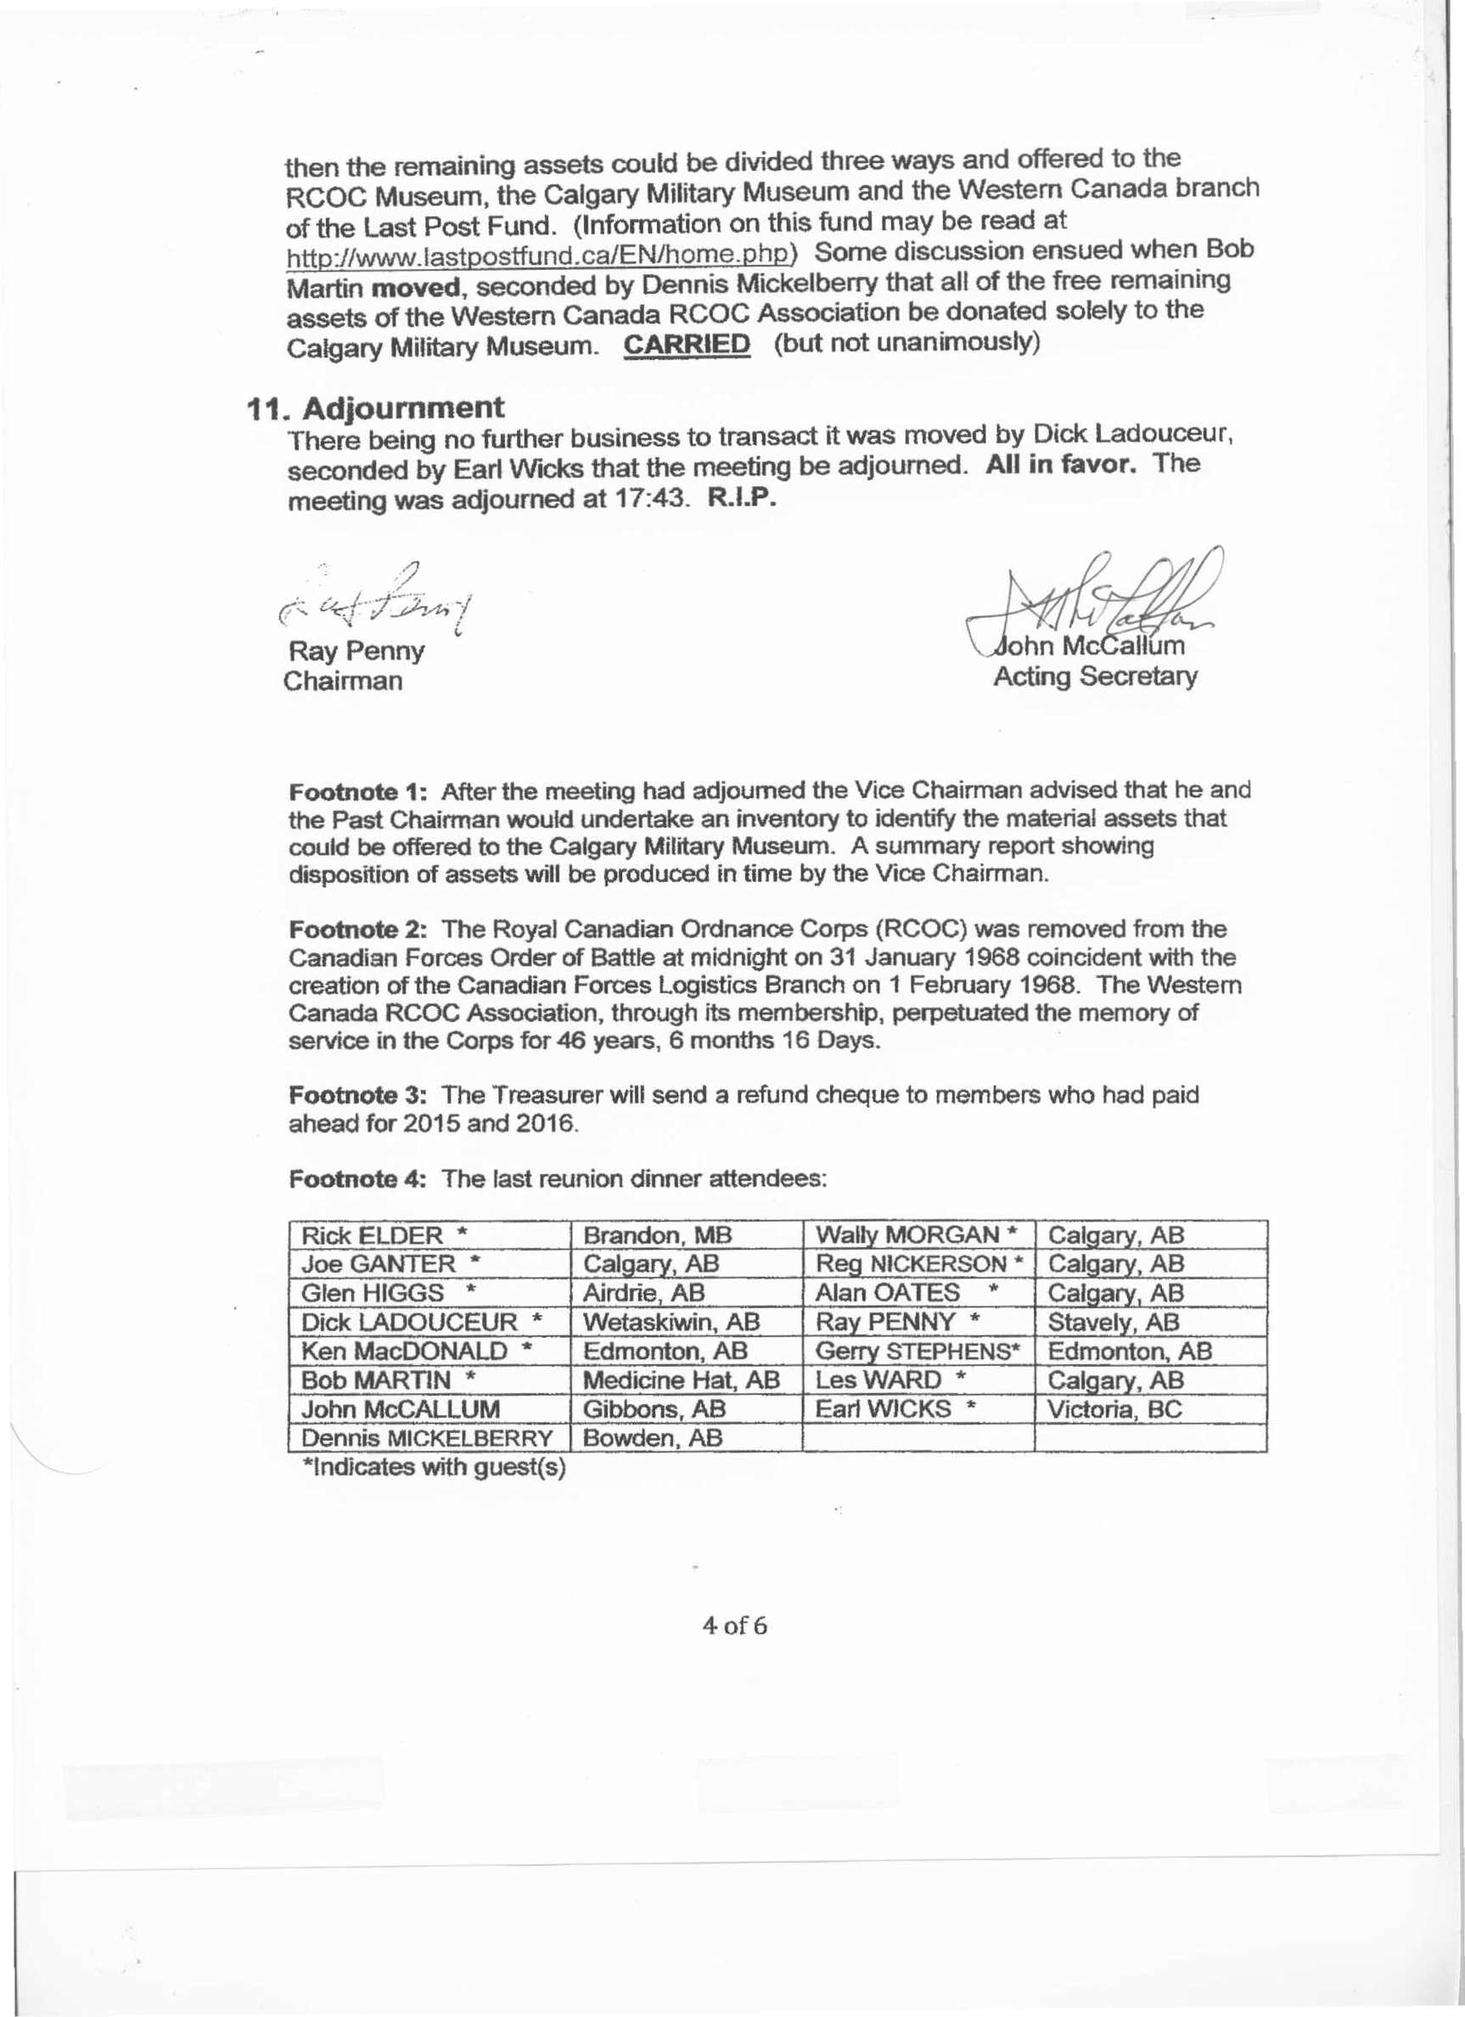

Some discussion ensued when Bob Martin moved, seconded by Dennis Mickelberry that all of the free remaining

assets of the Western Canada RCOC Association be donated solely to the Calgary Military Museum. CARRIED (but not unanimously)

There being no further business to transact it was moved by Dick. Ladouceur, seconded by Earl Wicks that the meeting be adjourned. All in favor. The

meeting was adjourned at 17:43. R.I.P.

f'.:.. *v-c(o;/:;h/f-i j*

Ray Penny Chairman

Acting Secretary

Footnote 1: After the meeting had adjourned the Vice Chairman advised that he and the Past Chairman would undertake an inventory to identify the material assets that

could be offered to the Calgary Military Museum. A summary report showing disposition of assets will be produced in time by the Vice Chairman.

Footnote 2: The Royal Canadian Ordnance Corps (RCOC) was removed from the Canadian Forces Order of Battle at midnight on 31 January 1968 coincident with the

creation of the Canadian Forces Logistics Branch on 1 February 1968. The Western Canada RCOC Association, through its membership, perpetuated the memory of

service in the Corps for 46 years, 6 months 16 Days.

Footnote 3: The Treasurer will send a refund cheque to members who had paid ahead for 2015 and 2016.

Footnote 4: The last reunion dinner attendees:

Rick ELDER * Joe GANTER ."

Glen HIGGS •

Dick LADOUCEUR * Ken MacDONALD *

Sob MARTIN ." John McCALLUM

Dennis MICKELBERRY *Indicates with guest(s)

Brandon, MB Calgary, AB

Airdrie AB Wetaskiwin, AB

Edmonton, AB Medicine Hat, AB

Gibbons,AB Bowden,AB

Wally MORGAN * Reg NICKERSON •

Alan OATES Ray PENNY'"

Gerry STEPHENS· LesWARD ."

Earl WICKS •

Calgarv, AS Calgary, AS

Calgary AS Stave lv, AS

Edmonton, AS Caloarv,AB

Victoria, BC

by email or letter mail

50f6



Annex A

To AGM Minutes Dated 16 August 2014

**Membership**  **Chairman's**  **Report to AGM -16**  **August 2014**

When the previous Membership Chairman passed the files to me it included a spreadsheet containing 136 entries of present, recent past and long lapsed members.

There were 53 who had not been heard from for several years. (136-53=83)

Discounting the 53 who had not been active within the past **three** years this resulted in a known actual and potential association membership **base** of 83 which was

suddenly reduced to 82 with the recent passing of Norm Litke. We did pick up a new member yesterday to bring our actual and potential membership base back to 83.

At the end of 2013, of that actual group of 83 relatively active members we had 71 paid up members. This was an (71/83*100=) 85.5% participation rate. At yearend

2013, of the total 136 actual and potential members [136-71 =] 65 had not been heard from.

In April 2014 all 136 actual, past and long lapsed potential members were contacted

.

In Maya corrected entertainment flyer was sent out

In June those with email addresses still not heard from were sent a reminder.

Three contacts in three months.

Of all 136 contacted 3 provided feedback that they no longer wished to be contacted by the association. 50 have renewed their membership for 2014, leaving 83 not

heard from. Overall 18 more than last year wouldn't take the time to contact the association. I will no longer attempt to contact any past member who has not been

active within at least the past 3 years.

Included in the current paid membership count are 3 brand new members and 2 long time lapsed members who have rekindled their paid up memberships.

As of today, 16 Aug 2014, of our current and recently active potential 83 members there are 51 paid up members of the Western Canada RCOC Association. This is a

loss of 20 paid up members compared to the paid up membership at the end of 2013 which was 71. This is a (51/83*100=) 61.4% participation rate. Recall as stated

above we had an 85.5 participation rate last year. The active membership downward trend continues.

Honorary Members: Georgina McAdam, Sally Poole

This concludes my report. Jo~:Um,

MembershipChairman.

**Recen Iy**

MULLIN,

***2013/2012***

**C**

6of6



**MEMBERSHIP**  **AT DISOLUTION**

**Active in 2014**

AITKEN, Don ALLEN, Gerry

CORNFORTH, Phil ELDER, Rick

GANTER, Joe GEORGE, Wally

GRACE, Mike HARPER, Bill

HARRISON, Murray HART, Bob

HICKS, Bill HIGGS, Glen

HOOD, Bill JACKSON, Stanley

LADOUCEUR, Dick LANGLOIS, *Jeff*

LEFURGEY, Jim LEMYRE, Jack

LUNDIN, Rick LYST AR, James

MacDONALD, Ken MARTIN, Bob

MARTIN, JJ McCALLUM, John

McDOWELL, David MICKELBERRY,

Dennis

KELOWNA, BC LOMOND, AB

VICTORIA, BC BRANDON,MB

CALGARY,AB CALGARY, AB

CALGARY, AB EDMONTON, AB

BEAUSEJOUR, MB CALGARY, AB

CHAUVIN, AB AIRDRIE, AB

CALGARY, AB KINGSTON, ON

WETASKIWIN, AB CALGARY, AB

CALGARY, AB RICHMOND, BC

OSOYOOS, BC LONDON, ON EDMONTON, AB

MEDICINE HAT, AB CALGARY, AB

GIBBONS, AB UNION BAY, BC BOWDEN, AB

MORGAN, Walter MOTTERAM, Ron

MOYLES, Jim

Gary (Moon) NICKERSON, Reg

OATES, Alan OELRICH, Ken

PADLEY, Garry PENNY, Ray

PERRAULT, Lewis PEWTRESS, Ruth

PICKUP, Bob PINSENT, John

SAMSON, Grant SKALICKY, Marg

STEPHENS, Gerry STINSON, David

STURGE, Tom SWANSON, Dave

TUDOR, Harry WARD, Les

WARREN, John WICKS, Earl WILSON, John YOUNG, Jim

CALGARY,AB CALGARY,AB

BURNABY, BC St. Georqe, NB

CALGARY,AB CALGARY,AB

CALGARY,AB CALGARY, AB

STAVELY, AB LETHBRIDGE, AB

CALGARY,AB CALGARY, AB

EDMONTON, AB VICTORIA, BC

CALGARY, AB EDMONTON, AB

SIDNEY, BC NANAIMO, BC

CALGARY,AB QUALICUM, BC

CALGARY, AB KANATA,ON

VICTORIA, BC CALGARY,AB CALGARY, AB

**tl**  **Aft** rve **0**

BAUER, Marion BELL, Raymond

BISHOP, Ron BOGLE, Len

BRAUN, Doug CADMAN, Jack

DUFF, Carl ENMAN, Bob

FORTIN, Robert

GRANT, Walter HARDING, Garry

JARCO, Ludwik JENKINS, Roger

KALENCHUK, Bill LlTTKE, David

MAINWARING, Paul

CALGARY, AB CALGARY, AB

CALGARY, AB WAINWRIGHT, AB

SAANICHTON, BC CALGARY, AB

GANANOQUE, ON OKOTOKS, AB

ST-JEAN-SUR- RICHELIEU , QC

SUTTON WEST, ON WINNIPEG, MB

KEEWATIN, ON WAINWRIGHT, AB

REGINA, SK CALGARY,AB

NAGAMBIE, VICTORIA, AU -

MANIQUET, Tex MARSHALL, Ford

METHERAL, Ken MONETTE, Romeo

MYSLICKI, Walter NIELSEN, Jan

NOLAN, Anthon_y_ PAVEY, Gerry

POLISCHUK, Jack

PUTTICK, Keith RHODES, PV (Dusty)

SAULNIER, Paul STRAIGHT, Rod

SZOVA, Miklos

WILSON, Moe

ANGUS, ON IRRICANA, AB

SURREY,BC OTTAWA, ON

HIGH RIVER, AB LOWERSACKVILLE,NS

ALDERGROVE, BC CHILLIWACK, BC

WINKLER, MB

CALGARY, AB CALGARY,AB

MONCTON, NB CALGARY,AB

WALNUT CREEK, CA PICTURE BUTTE, AB